INTERESTED IN VOLUNTEERING TO JOIN AN ARCHAEOLOGICAL DIG?
JOIN THE EXCAVATIONS AT GLAC IN SERBIA IN SEPTEMBER TO NOVEMBER 2019.

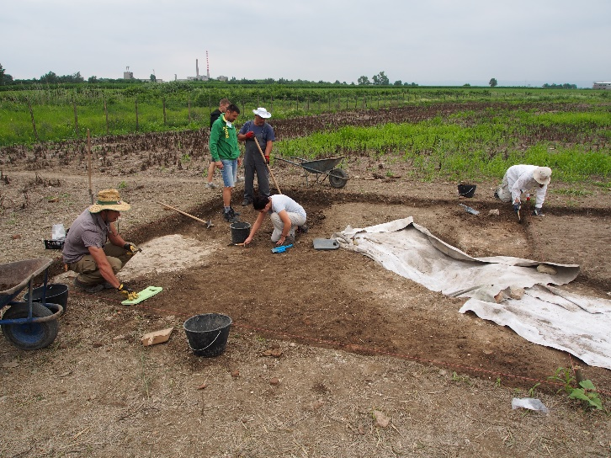
Expressions of interest are invited from students from the University of Belgrade in Archaeology, Classics and related fields to join excavations of a significant late Roman site in northwestern Serbia.
The University of Sydney and the Institute of Archaeology in Belgrade are jointly conducting these excavations, now in their third year. The joint Australian – Serbian team is led by Professor Richard Miles from Sydney University and Dr Stefan Pop-Lazić from the Institute of Archaeology.
The site of Glac is located on the outskirts of the modern city of Sremska Mitrovica in western Serbia. The city is the ancient city of Sirmium. Under Emperor Diocletian’s Tetrarchy, Sirmium was one of the 4 capitals of the Roman Empire. The ancient historian Ammianus Marcellinus called Sirmium "the glorious mother of cities". Glac is a huge late Imperial villa palace, next to the Sava River. It is thought to be the palace mentioned by Aurelius Victor as built by Maximian, Roman Emperor from 286 to 305, in the place where his parents lived. The site was occupied long before the late Imperial palace and well afterwards.
The 2019 excavation season will be from Friday 27 September until Monday 4 November 2019, with the need to allow one day either side of these dates for travel to and from Belgrade. You will work with an enthusiastic and talented multi-national team and be trained in excavation techniques. The team works 6 days a week, with each Sunday a free day, giving you the opportunity to explore neighbouring sites. The team is accommodated in shared facilities in Sremska Mitrovica.
The costs for transport to and from Belgrade, accommodation and all meals (except for lunch and dinner on Sundays and any other personal expenses) will be met by the Pannonia Project from Sydney. Volunteers would need to be able to commit to the entire excavation season.
If you are interested in being a volunteer in the Australian team, please email Dr Milijan Dimitrijević, Project Researcher from the Pannonia Project at milijan.dimitrijevic@sydney.edu.au by 30 June, 2019 with the following information:
- Full name and address.
- Date of Birth.
- Academic / professional qualifications or subjects completed.
- Details of any previous archaeological experience.
- Reasons why you would like to participate in the Glac excavations.
- A copy of your current resume /CV.
- Name of a referee within the University.
Any further information may be obtained from Dr Milijan Dimitrijević. Applicants should be able to communicate in the English language.

